'''

Elimination Tournament Scheduler

A tournament where winner is decided by eliminating a competitor every match and

where competitors compete in a 1v1 manner (like a chess or badminton tournament)

~~for now, n is the number of input that is supported.~~

~~n can be of the form 2^x , where x is 0,1,2,3...~~

Input is n, number of participants, and a list of names of participants.

Things to Achieve

1. No of levels

can be calculated as next power of 2 (using below research)

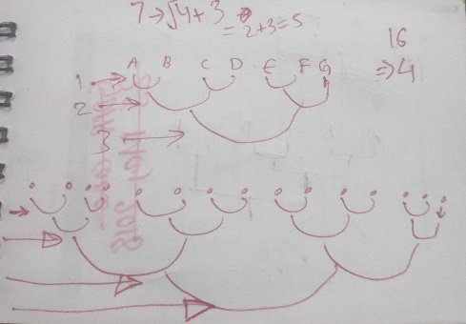

Exp. if n is 4, 2 levels are required as next power of 2 is 4, so 2.

If n is 7, 3 levels are required as next power is 8, so 3.

'''